This repository contains the code for building a Netflix-inspired home page using HTML and CSS. The project aims to recreate the visual design and layout of the Netflix home page, providing a starting point for creating similar interfaces or learning web development techniques.

**Preview**

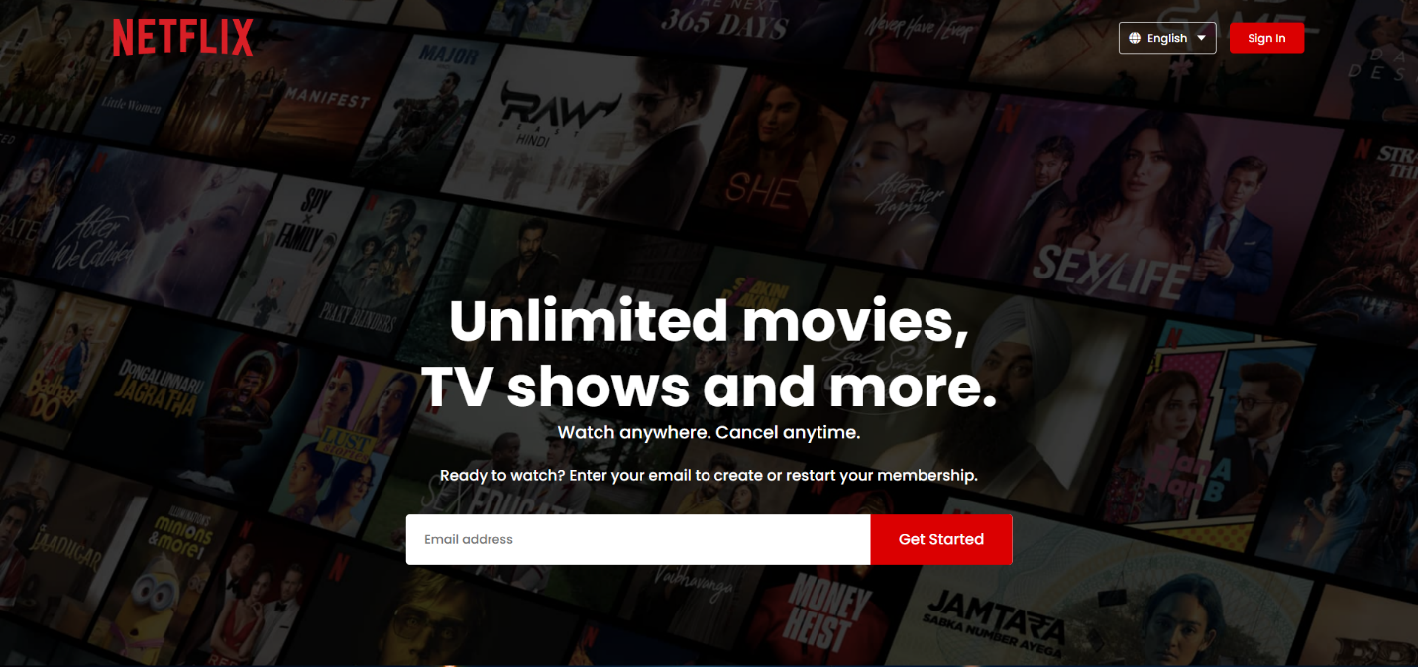

**Features**

* Responsive design: The web page adapts to different screen sizes, ensuring a consistent user experience on desktop and mobile devices.
* Interactive components: The page includes interactive elements such as buttons, dropdown menus, and hover effects.
* Dynamic content: Placeholder content is used to mimic Netflix's movie and TV show recommendations.
* CSS styling: The stylesheets provide a sleek and modern look, resembling the Netflix branding.

**Getting Started**

To get started with this project, follow these steps:

1. Clone the repository: https://github.com/NeveshGupta0312/Netflix-website-
2. Open the project in your preferred code editor.
3. Launch the index.html file in a web browser to view the Netflix home page.
4. Feel free to modify the code and customize the page according to your preferences. You can update the content, change the colors, or add new features.

**Contributing**

Contributions to this project are welcome. If you find any issues or have suggestions for improvements, please open an issue or submit a pull request.

**Acknowledgements**

* The design and inspiration for this project come from the official Netflix website.
* Special thanks to the open-source community for providing helpful resources and tutorials on web development.

**Contact**

If you have any questions, suggestions, or feedback, you can reach out to the project maintainer:

* Your Name : NEVESH GUPTA
* Email: [guptanevesh@gmail.com](mailto:guptanevesh@gmail.com)